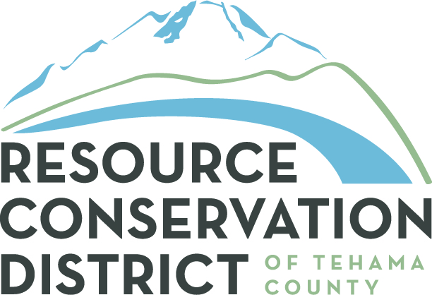 RESOURCE CONSERVATION DISTRICT of TEHAMA COUNTY

2 Sutter Street, Suite D ♦ Red Bluff, California 96080 ♦ 530-527-3013 ♦ Fax: 530-527-7451

Date: April 12, 2017

To: Tehama West/Tehama East Community Wildfire Protection Plan Reviewers

Re: Prioritization of Proposed Projects Described in the Tehama West/Tehama East Community Wildfire Protection Plan

Thanks again for your assistance in reviewing the Resource Conservation District of Tehama County’s recently updated fire plan documents for Tehama County. The combined Tehama West Community Wildfire Fire Protection Plan and Tehama East Community Wildfire Protection Plan was prepared in order to update the original 2005 Tehama West Fire Plan and convert that document into a formally recognized Community Wildfire Protection Plan. Similarly, the Tehama East Community Wildfire Protection Plan updates information found in the original fire planning document completed in 2008. Both updated plans were developed utilizing input and information provided by members of the Tehama-Glenn Fire Safe Council and other stakeholders located throughout Tehama County and the surrounding area. A Countywide base map has been developed that display the resources within Tehama County at significant risk of wildland fire along with a representation of the completed, in process and planned/proposed projects described in the combined fire plan document. A map of the fire planning units developed for this effort has been prepared as well. In order to assure that the combined fire plans and Base Map provide a complete and accurate picture of the current fire and fuels management situation in our County, the RCD of Tehama County submitted a review draft of both documents to members of the community who expressed an interest in fire and fuels management planning efforts.

Now that the revised planning document and Base Map have been completed and reviewed, it would be appreciated if you would prioritize those proposed projects in the watershed/s that are of particular interest to you using the attached Prioritization Worksheet. Once the worksheets have been returned and compiled, a final version of the worksheet will be incorporated into the published combined fire plan document along with the County Base Map and map of the planning units. If you could review the fire plan, prepare the attached Prioritization Worksheet and return it to the RCD of Tehama County by May 1, 2017 it would be greatly appreciated. You can submit the worksheet via email to tom@tehamacountyrcd.org or mail it to:

Tom McCubbins
Project Manager
Resource Conservation District of Tehama County
2 Sutter Street, Suite D
Red Bluff CA 96080

Please let me know if you have questions or comments related to the Tehama West/Tehama East Community Wildfire Protection Plan Update Prioritization Worksheet or the planning documents them self. In addition to email, I can be reached at 530-200-1231. Thanks again for your assistance in this final phase of the Tehama West/ Tehama East Community Wildfire Protection Plan update process.

Sincerely
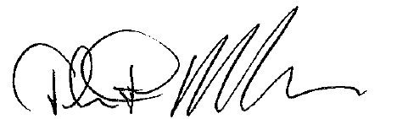
Tom McCubbins
Project Manager
Resource Conservation District of Tehama County

